|  |
| --- |
|  |

|  |
| --- |
| **Connected Parties** |
|  |
|  |
|  |
|  |
| **2/4/2014** |
|  |

Contents

Table Of Figures 2

Introduction 3

**Assumptions** 3

Connected Parties Launching and Logging 5

**Launching** 5

**Logging In** 5

Key Members 6

Connected Parties 10

**Exiting** 12

# Table Of Figures

Figure 1: Login Screen 5

Figure 2: Populated Login Screen 5

Figure 3: Create New Key Member 6

Figure 4: Populated Add Key Member Screen 7

Figure 5: Key Member Tenures Grid Data 8

Figure 6: Edit Key Member Screen 9

Figure 7: Create Connected Party 10

Figure 8: Key Member and Connected Party Relationship 10

Figure 9: Key Member’s Connected Parties Data Grid 11

Figure 10: Deleting Key Member’s Connection 11

Figure 11: Exit Application 12

# Introduction

This is application was designed in conjunction with Depend to maintain history of Key member and their Connected Parties. The application was created to maintain key members for each instrument and their connected parties. It will also store the key member history of multiple appointments and resignations. The instructions outlined below will give an end user a working knowledge of how to operate the application.

**Assumptions**

This user guide is designed based on the following assumptions:

1. The user has a working knowledge of Depend and has a valid login credential.
2. The application is installed.

**Note: All installation and configuration for the software must be done by the I.T. Department.**

*Connected Parties Revision Table*

|  |  |  |  |
| --- | --- | --- | --- |
| Version | Date | Description | Author (s) |
| 1.0 | 10/04/2012 | Initial Release | Tafari Johnson |
| 1.1 | 10/02/2014 | Key Member Module added | James Duncan |

# Connected Parties Launching and Logging

**Launching**

To launch the Depend Price Upload Application, please follow the steps outlined below:

1. Double-click on the Depend Price Upload Application icon located on your desktop or navigate to START->ALL PROGRAMS->JCSD->Connected Parties.
2. When the application launches, the following screen appears.

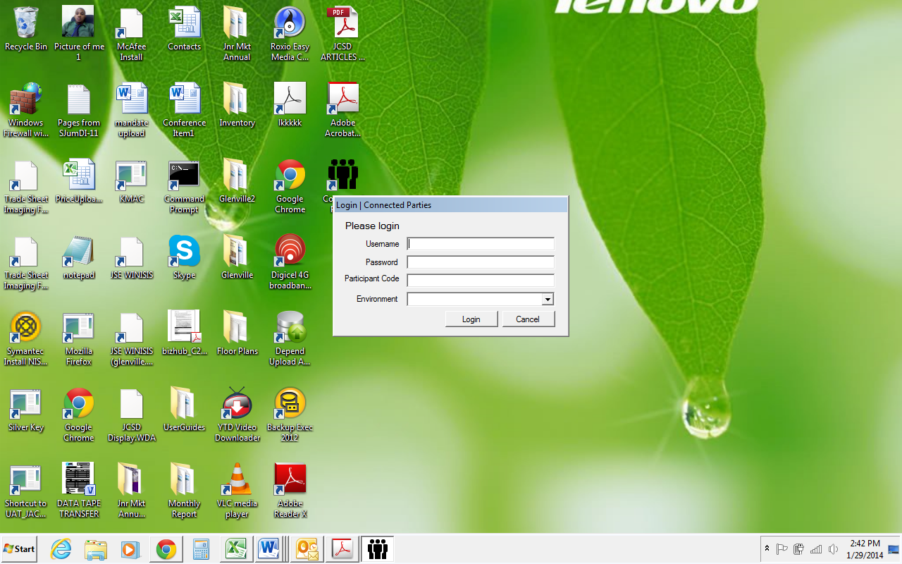

Figure : Login Screen

**Logging In**

To log on enter your Depend credentials.

**Note: The participant is *RSU****.* Once all the information has been entered click the Login button.

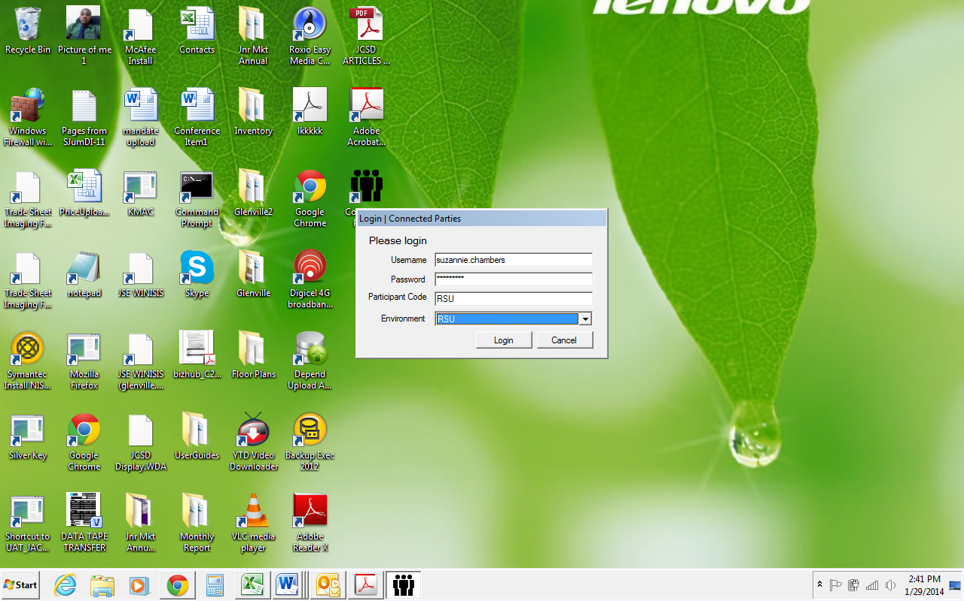

Figure : Populated Login Screen

# Key Members

The key members tab allows the user to do the following:

1. Create New Key Member – This function allows the user to register a new **Key Member**. Select **Create New Key Member** to start the process.

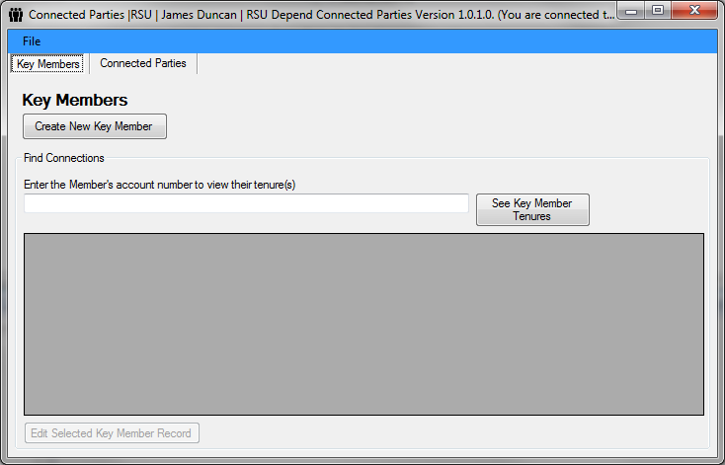

Figure : Create New Key Member

1. New Member – Enter all information necessary to create a new member. Once all necessary information is added select the **Add Member** tab. Once the Add Member is selected a message will pop up stating that the connection has been saved, click OK to remove the screen.

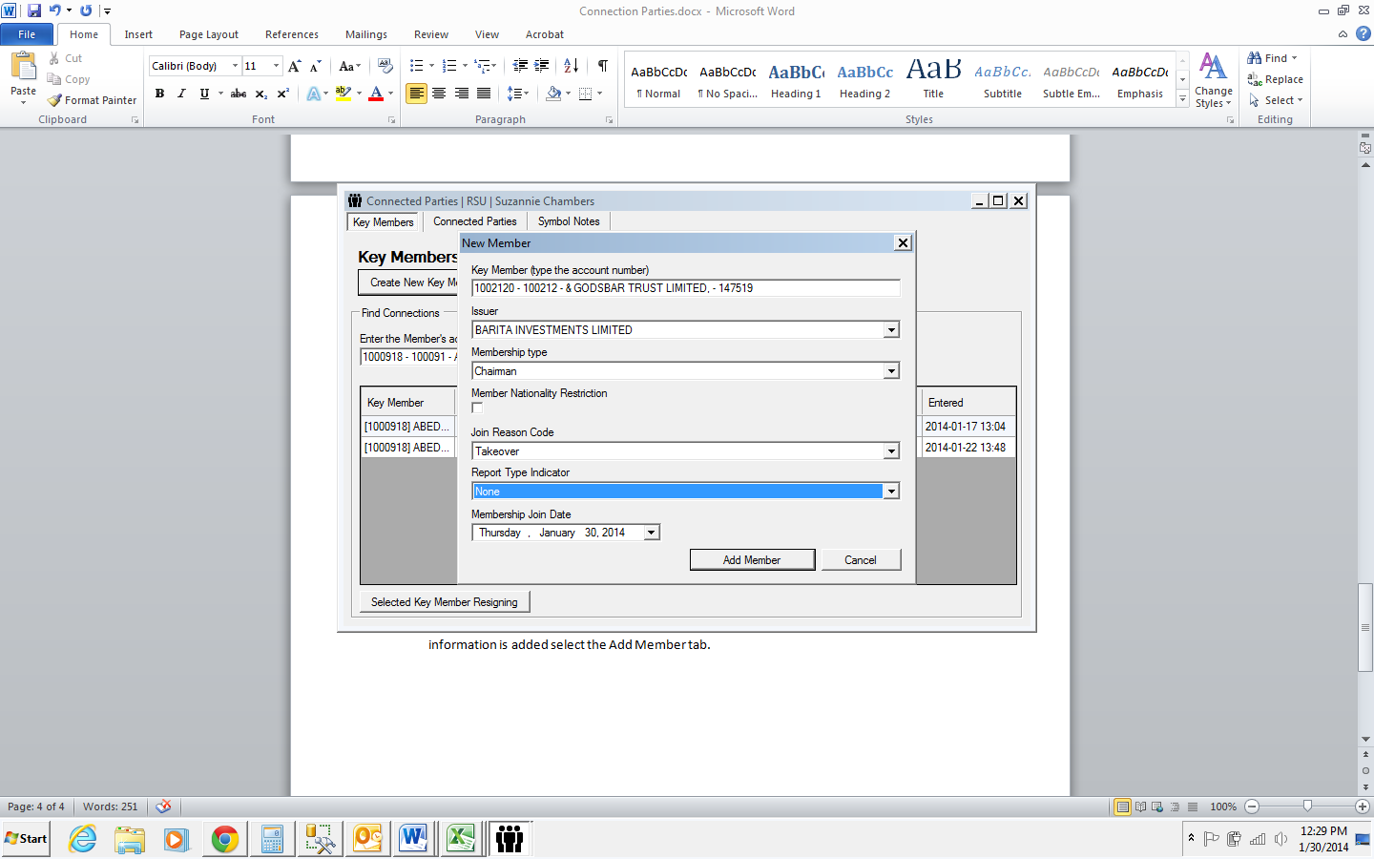

Figure : Populated Add Key Member Screen

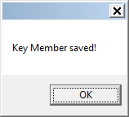

1. See Key Member Tenures – this function allows the user to view the tenure (s) of a member using their account number. Enter the account number in the field provided and select the **See Key Member Tenure** button. Once the account number is entered the user will now be able to view the member (s) information in the grid area.

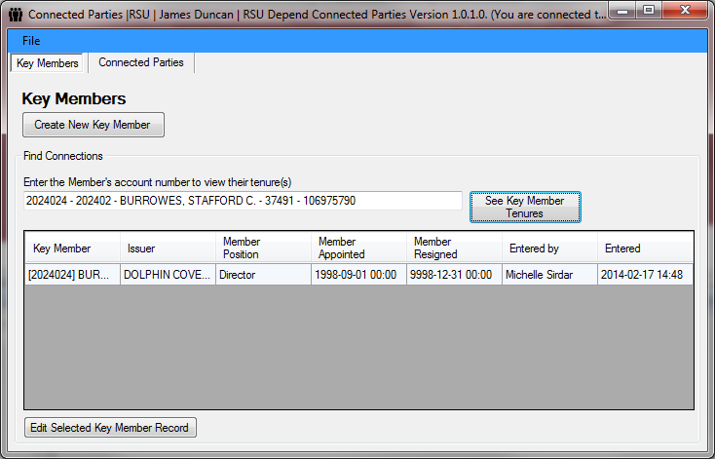

Figure : Key Member Tenures Grid Data

1. Edit Selected Key Member Record - this function allows the user to update a keymember record. The user first has to repeat the previous step (see iii), once this is done, the user must select the key member in the grid area, then select the **Edit Selected Key Member Record** button. Once this is done, the following screen will appear.

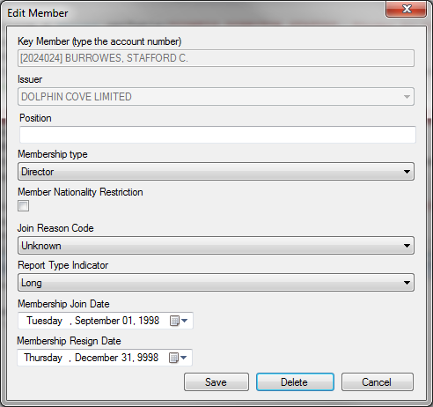

Figure : Edit Key Member Screen

Make the necessary changes and select save button to update the record, the delete button is used to delete the record from the system.

**N.B.: The Membership Resign Date will automatically have the current date populated in the**

**field**.  **Select the drop-down and select the actual resignation date if the member has resigned.**

Once the user select the save or delete button, a message screen will pop up notifying the user the change they are about to execute. Click OK to confirm.

# Connected Parties

The following tab allows the user to the do the following:

1. Create New Connection – this function allows the user to create and maintain a connection between a key member and associates. Select **Create New Connection,** has shown below.

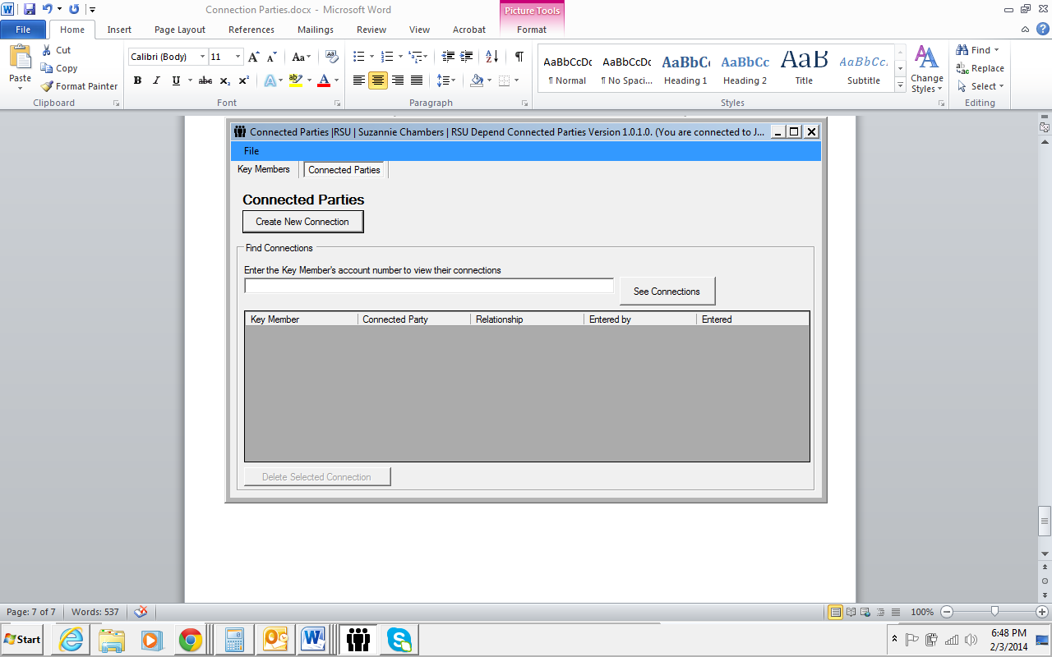

Figure : Create Connected Party

1. Once the user has selected the Create New Connection button, the New Connection window will appear. Enter the key member and connected party account number as well as the relationship between two parties (*to select the type of relationship, click the drop down and enter the information*). Once the information have been added, select Create Connection and a new connection will now be created. A message will pop-up stating the connection has been saved.

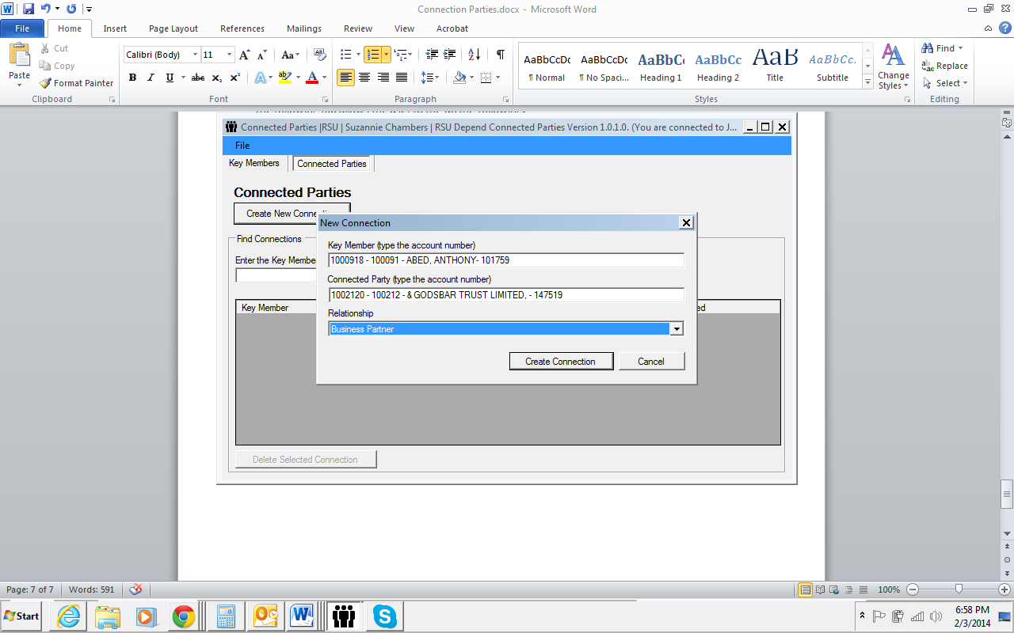 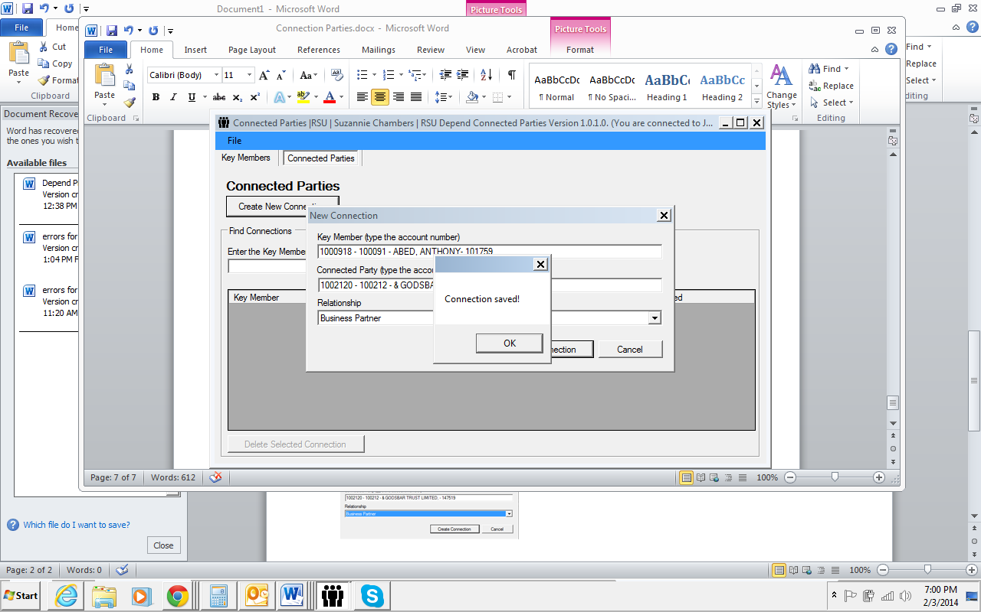

Figure : Key Member and Connected Party Relationship

1. Deleted Selected Connection - this function allows a user to delete a connection created between two parties. Below are the steps outlined to delete a connection:
2. Enter an account number in the field provided
3. Once account number is entered select the see connection button. The information relating to the account number entered will be displayed in the grid.
4. Select the connection that will be deleted from the grid and then select **Delete Selected Connection,** a message screen will now appear prompting the user to delete or not. Click YES to delete or no if you do not want to delete.

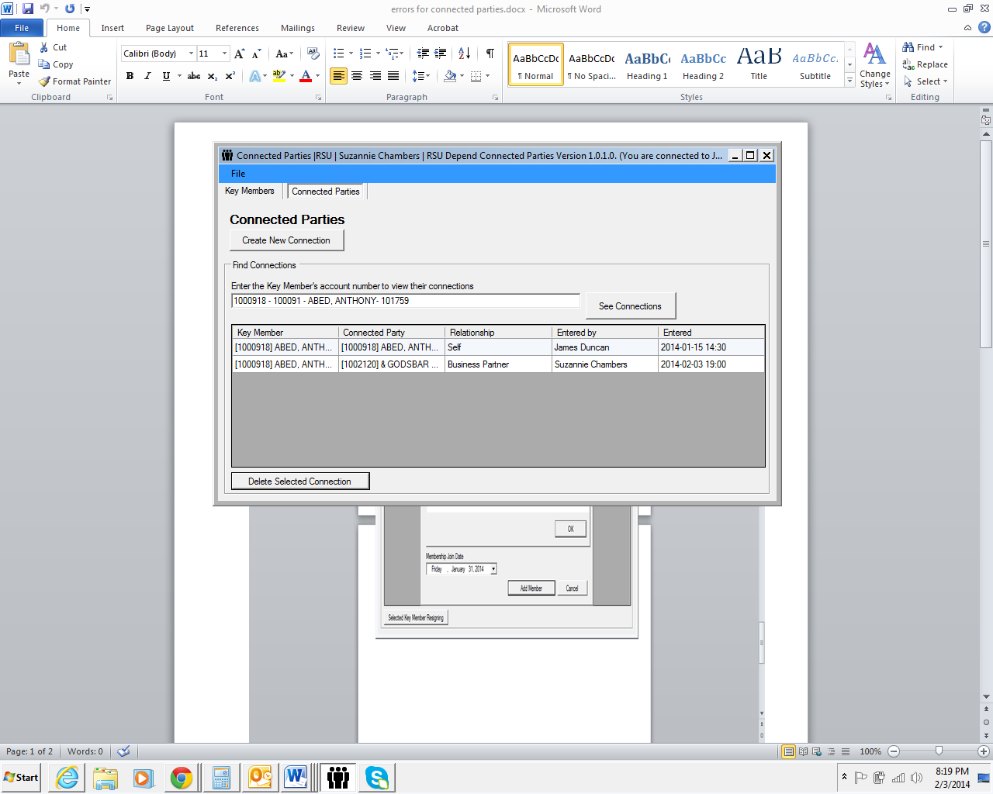

Figure : Key Member’s Connected Parties Data Grid

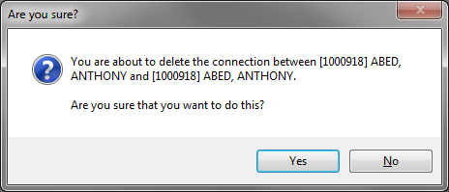

Figure : Deleting Key Member’s Connection

**Exiting**

To exit the application:

1. Go to **File** and select **Exit**

**OR**

1. Exit the application by clicking the **X** tab as indicated on the screen below.

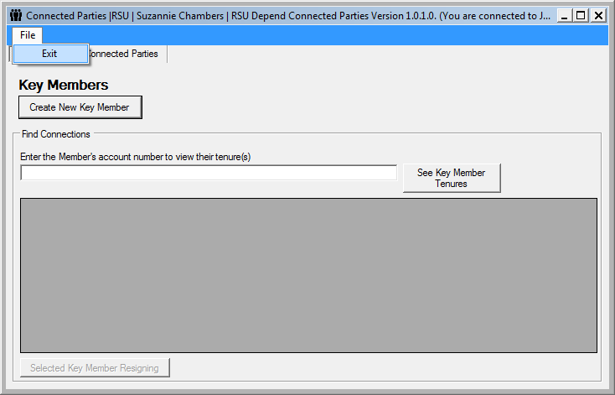

Figure : Exit Application